Politecnico di Torino

Department of Management and Production Engineering
Bachelor's Degree in Management Engineering
Class L-8 Information Engineering
Academic Year 2025/2026
Graduation Session November 2026

Application for the logistic and economic optimisation of car upgrades in Formula 1

Supervisor: | Candidate:
Prof. Averta Giuseppe Bruno | Alessandro Russo  Student ID: s328917

Contents
1. Project title and student details 3
2. Project proposal 4
2.1 Text of the approved proposal 4
2.2 Changes and additions made during the work 6
3. Description of the problem addressed 7
3.1 Operational context 7
3.2 The problem addressed 8
3.3 Critical issues, potential and relevance 8
4. Description of the dataset 10
5. Data structures and algorithms 12
5.1 Evaluation model 12
5.2 Constraints 13
5.3 Data structure: the graph 13
5.4 Algorithm 14
6. Class diagram 16
7. Application screenshots and demonstration video 19
7.1 Pre-Season mode 19
7.2 In-Season mode 22
7.3 Demonstration video 23
8. Experimental results 24
8.1 Test configuration 24
8.2 Target position 24
8.3 Available budget 25
8.4 Performance tolerance 25
8.5 Development start date 26
8.6 Season 27
8.7 Team base 27
8.8 Debut choice in the In-Season mode 28
8.9 Computation times 28
9. Evaluation and conclusions 29
9.1 Strengths 29
9.2 Weaknesses 29
9.3 Contribution to the problem 30
9.4 Conclusions 30
References 31

1. Project title and student details
Title | Application for the logistic and economic optimisation of car upgrades in Formula 1
Student | Alessandro Russo
Student ID | s328917
Institutional e-mail | s328917@studenti.polito.it
Personal e-mail | 37alerusso@gmail.com
Degree programme | Management Engineering (L-8), Politecnico di Torino, Academic Year 2025/2026
Final project | Programming Techniques (Tecniche di Programmazione)
Repository | https://github.com/TdP-prove-finali/RussoAlessandro
Demonstration video (it) | https://youtu.be/n1bTftE29iw
Licences | Report: Creative Commons BY-NC-SA 4.0  Software: Apache License 2.0  Data: CC BY-NC-SA 4.0, base data from Jolpica F1 through the Kaggle dataset  Road routes: ODbL, © OpenStreetMap contributors

2. Project proposal

2.1 Text of the approved proposal
Proposing student
s328917 Russo Alessandro
Title of the proposal
Application for the logistic and economic optimisation of car upgrades in Formula 1
Description of the proposed problem
In the modern Formula 1 championship, the optimal management of resources (both before and during the season) makes the difference between a winning year and a failed one. This project addresses the problem of how and when to introduce technical upgrades on the cars. Teams must comply with the rules set by the FIA (such as the Budget Cap) and take into account strategic constraints on where and when to bring the changes. The goal is to create an application that helps decide the best circuit and time slot for the debut of a new component, avoiding inefficiencies (such as bringing a new wing to an unsuitable track or to one with a high risk of rain).
Description of the managerial relevance of the problem
The problem has considerable managerial relevance, since the organisational factors related to the production of parts have a direct impact both on track performance and on the team's finances. The application will help treat new components not only as mechanical parts but as investments. The program will in fact estimate a Return on Investment (ROI): the managerial objective is to spend the budget so that the new part brings a real lap-time gain for as many races as possible, amortising its cost.
Description of the data sets for the evaluation
The evaluation of the model will be based on a relational database structured in 3 tables: circuits, races and components. The base data for the first two tables come from the public historical dataset available at the following link: https://www.kaggle.com/datasets/patelris/formula-1-complete-dataset-1950-2026?resource=download
The following customisations were applied to these raw data for the logic of the algorithm:
• Four attributes were added to the “circuits” table: three numerical indices representing the importance of aerodynamics, chassis and power unit for each track. Since no official public measurements exist, these three indices were derived by empirical estimation, based on a topological analysis of the tracks and on the technical motorsport literature. Finally, an attribute concerning the probability of rain (calculated with WeatherSpark https://it.weatherspark.com/), considering the period in which the circuit has historically hosted the Formula 1 championship.
• A Boolean value was added to the races table to indicate whether that specific weekend includes a “Sprint” race. This is a critical factor, since the Sprint format drastically reduces the time available to test new upgrades.
• For this reason, the most recent Formula 1 seasons (from 2021 onwards) were considered.
The “components” table will act as the reference catalogue for technical decisions. It will contain the classification of the packages by size and area of focus, associating with each type the cost constraints under the Budget Cap and the standard production times. The cost values were sized realistically with respect to the macroscopic constraints of the Budget Cap imposed by the FIA Financial Regulations, a consistency needed to validate the ROI optimisation.
Preliminary description of the algorithms involved
The application requires the development of a constrained optimisation algorithm. The input parameters will be processed by cross-referencing them with the relational database. The central algorithmic problem consists in analysing the spatio-temporal combinations in order to identify the optimal Grand Prix for the debut of a technical upgrade. The objective function aims to maximise the performance Return on Investment (ROI), subject to strict constraints: the physical production times of the part, the compatibility between the component and the characteristics of the track, the probability of adverse weather and the presence of the Sprint format.
Preliminary description of the planned features of the software application
User interaction with the application will revolve around the input of key decision parameters. The primary action will consist in using a switch to set the time context of the operation. This control will direct data entry towards two distinct operating modes.
By selecting the Strategic Planning mode (Pre-Season), the user will configure the initial macroscopic parameters. Specifically, the user will enter the reference year of the championship, the annual development budget available and the target position in the Constructors' Championship, a key parameter that allows the algorithm to calculate the aerodynamic handicap and the related limits on simulation hours. Finally, the user will fill in a “Wishlist” of upgrades, specifying for each planned package the size of the investment and the technical focus.
If instead the Tactical Recalculation mode (In-Season) is activated, data entry will adapt dynamically to handle reactions during the championship. In this scenario, the user will provide the system with the current Grand Prix, which will act as the temporal starting node, the actual championship position at that precise moment and the remaining budget actually available. To these context data will finally be added the characteristics, again in terms of size and technical focus, of the single urgent component to be approved.

2.2 Changes and additions made during the work
Compared with the approved proposal, the general approach of the project has remained unchanged. The changes mainly concern the criterion used to assess the convenience of a development plan and the addition of some data, needed to make the model closer to reality.
The most significant change concerns the objective function. The optimisation process is divided into two phases: the first determines the maximum performance gain achievable; the second, accepting a reduction in performance not greater than a tolerance set by the user, identifies the solution offering the best trade-off between gain and cost. The direct maximisation of the ROI, envisaged in the proposal, tended in fact to favour small packages and to leave part of the available budget unused. The ROI nevertheless remains among the results reported for each package.
The development areas considered have been reduced to aerodynamics and chassis. The power unit is in fact developed by the engine manufacturer and does not fall within the team's cost cap: it is therefore not a decision lever within the scope of the model. The power unit index has nevertheless been kept in the database for descriptive purposes.
As regards the budget, the user no longer enters the amount allocated to development directly, but the other expenses expected in the season; the budget available for upgrades is obtained by difference from the cost cap set by the Financial Regulations, so as to guarantee compliance with the cost cap. This change allows a more accurate estimate of the resources actually available, since the team knows its annual fixed costs and can forecast the variable ones with good approximation.
The costs of the catalogue have also been redefined: instead of being sized realistically, they are calculated from the costs of the individual components modified by each package, obtained from public sources.
The logistic component has also been introduced explicitly. Starting from the base of the selected team, the model determines for each Grand Prix the means of transport, the time and the cost of shipping the new components from the factory to the circuit. To this end, the database has been extended with two tables, containing respectively the teams with their bases and the routes between bases and circuits, and the 2027 season has been added, adopted as the reference for the demonstration.
Finally, the input parameters envisaged in the proposal are complemented by the team, needed for the logistic calculation, the performance tolerance, used in the second phase of the optimisation, and the development start date.

3. Description of the problem addressed

3.1 Operational context
In the Formula 1 championship the car is designed during the winter, but it keeps evolving throughout the season. Teams periodically introduce upgrade packages, that is, sets of modified components such as the front wing, floor, bodywork, suspension or braking system, which improve the performance of the car. Each package requires weeks of design and production and, once brought to the track, must be validated in real conditions.
Validation takes place during the race weekend. In a traditional weekend, Friday and Saturday morning are devoted to three one-hour free practice sessions, followed by qualifying on Saturday and the race on Sunday. Free practice is the only moment in which the team can directly compare the new components with the previous ones, check that the behaviour on track matches what was predicted in the wind tunnel and in simulations, and define the set-up for the rest of the weekend.
The Sprint format significantly reduces this margin. Since 2024 a Sprint weekend has included a single free practice session, followed by Sprint qualifying and the Sprint race, and then by qualifying and the main race [1]. The team therefore has one hour instead of three to evaluate the new package before the results start to count. The competitive sessions still provide useful data, but they do not allow comparative tests. For this reason the Sprint weekend is considered unsuitable for the debut of an upgrade [2].
Rain has a similar effect. Data collected on a wet track are not representative of the behaviour of the car in the dry, the condition for which upgrades are designed: a wet session does not contribute to their validation. The probability of precipitation in the period in which each Grand Prix takes place, obtained from historical climate data [3], therefore measures the risk that the debut weekend does not allow the package to be fine-tuned. In both cases the package does not immediately deliver its full potential, and fine-tuning extends to the following Grand Prix.
Development also takes place within two regulatory limits. The first is the cost cap of the FIA Financial Regulations, which since 2026 has limited most of a team's annual expenditure to 215 million dollars [4]. The budget available for upgrades is therefore what remains after operating expenses. The second is the Aerodynamic Testing Restrictions (ATR) scale. It assigns each team a share of wind tunnel tests and computational fluid dynamics (CFD) simulations that increases as its championship position worsens, from 70% of the reference value for the leader to 115% for the last teams [5]. As a consequence, top teams face longer development times for aerodynamic packages.
The calendar varies from one season to the next, both in its composition and in the number of Grands Prix, between 22 and 24 in the seasons considered; the latter also affects the cost cap, which the regulations increase for each race above a set threshold [4]. Circuits reward aerodynamic efficiency or the mechanical behaviour of the car to different extents, and are located in places that can be very far apart: the new components must be shipped from the team's base to the circuit, by road or by air, with times and costs that depend on the distance.

3.2 The problem addressed
The project addresses a specific sub-problem of development planning. Given the set of upgrades the team intends to produce during the season (wishlist), the task is to decide in which Grand Prix each of them should debut. The decision is taken at two distinct moments:
• in pre-season planning, the Pre-Season mode, the plan for the whole wishlist is built, starting from the development start date;
• in the in-season recalculation, the In-Season mode, the debut of a single component is chosen starting from the current Grand Prix, taking into account the actual championship position and the expenses already incurred.
The inputs are the season, the team, the championship position, the other expected expenses, the composition of the wishlist (size and technical area of the packages), the development start date and the performance tolerance.
The output is the debut plan:
• for each included package, the assigned Grand Prix, the expected performance gain, the production and transport cost, the time margin and the ROI;
• for the excluded packages, the reason for the exclusion;
• a summary of the committed and remaining budget.
The model is described in detail in section 5.

3.3 Critical issues, potential and relevance
The difficulty of the problem lies in the interaction between packages. Bringing a debut forward increases the number of races in which the upgrade delivers a benefit. The calendar, however, imposes minimum production and transport times, the production line works on one package at a time and the budget generally does not allow the whole wishlist to be produced: each choice therefore constrains the following ones. The number of possible plans grows combinatorially with the size of the wishlist, and evaluating them requires combining heterogeneous information: times, costs, circuit characteristics and weekend conditions.
The application makes it possible to explore these alternatives in a few seconds and to compare different scenarios, for example by changing the team, the season or the performance tolerance. From a managerial point of view, it treats upgrades as investments: each package has a cost, a lead time and a return that depends on when and where it enters service. In a context governed by a cost cap, where inefficient choices cannot be offset by additional resources, allocating the budget and production time effectively is a direct competitive advantage.

4. Description of the dataset
The data used by the application are stored in a MariaDB relational database made up of five tables, whose structure is shown in Figure 1. The circuits, races and constructors tables derive from a public dataset on the history of Formula 1, extended with the attributes required by the model; the components and routes tables were built specifically for the project.
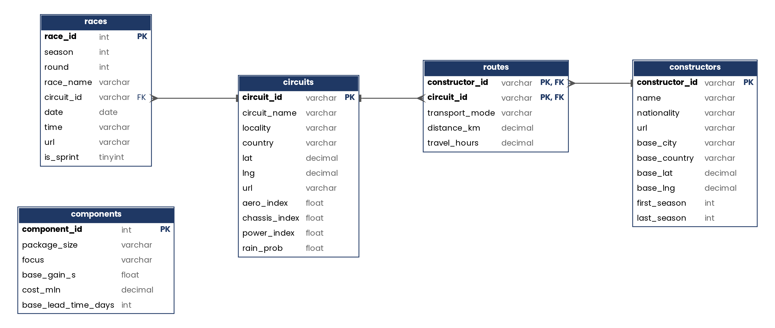
Figure 1 – Entity-relationship diagram of the database
The circuits table describes the circuits, with their location and geographical coordinates. Three indices between 0 and 10 have been added to these data, measuring how much each track rewards aerodynamic efficiency (aero_index), the mechanical behaviour of the car (chassis_index) and engine power (power_index). In the absence of official measurements, the indices were estimated from the characteristics of the tracks and from the technical literature, also taking into account the assessments published for each Grand Prix by the tyre and brake suppliers [6] [7]. The model uses the first two indices to evaluate the compatibility of a package with the circuit, while the third has a descriptive purpose. Finally, the rain_prob attribute reports the probability of rain in the period in which the Grand Prix takes place, obtained from historical climate series.
The races table contains the Grands Prix from 2021 to 2027, each with season, date, circuit and a Boolean attribute (is_sprint) indicating whether the weekend follows the Sprint format. The 2027 season, missing from the original dataset, was added from the official calendar.
The components table is the catalogue of upgrade packages. The six types result from the combination of three sizes (Minor, Medium, Major) with two technical areas (Aero and Chassis), as shown in Table 1. The gain, expressed in seconds per lap, is estimated from public statements by team engineers and managers. The cost is calculated by multiplying the number of modified components, including spare units, by their estimated unit cost. The lead time indicates the base design and production time, before the correction due to the ATR scale.
Table 1 – Catalogue of upgrade packages
Type | Gain (s/lap) | Cost (M$) | Base lead time (days)
Minor Aero | 0.05 | 0.60 | 14
Minor Chassis | 0.05 | 0.40 | 14
Medium Aero | 0.12 | 1.20 | 35
Medium Chassis | 0.12 | 1.40 | 35
Major Aero | 0.30 | 2.10 | 70
Major Chassis | 0.30 | 2.10 | 70
The constructors and routes tables support the logistic component of the model. The first contains the teams, with the city and coordinates of their technical base and the seasons in which they took part. The second reports, for each team–circuit pair, the means of transport planned for shipping the components: by road if the straight-line distance does not exceed 2,000 km, by air otherwise. For road routes the actual driving distance and hours are stored, calculated once with a routing service; for air routes, the straight-line distance.
Some regulatory data, namely the cost cap of each season and the ATR scale, are not stored in the database but in the constants module of the application, together with the model parameters.
The data sources and their licences are summarised below.
• Circuits, Grands Prix and teams: Formula 1 Complete Dataset 1950–2026, published on Kaggle [8] and derived from the Jolpica F1 API; CC BY-NC-SA 4.0 licence [9].
• 2027 calendar: official Formula 1 announcement [10].
• Probability of rain: WeatherSpark [3].
• Circuit indices: estimates based on the characteristics of the tracks, with reference to the Brembo [6] and Pirelli [7] assessments.
• Team bases: industry sources [11] [12].
• Package costs and gains: unit costs of the components [13]; public statements by engineers and managers [14] [15].
• Road routes: OSRM routing service on © OpenStreetMap contributors data; ODbL licence [16].

5. Data structures and algorithms

5.1 Evaluation model
Each package in the wishlist is described by a nominal gain, a production cost and a base lead time (Table 1). For aerodynamic packages the lead time is corrected according to the ATR share assigned to the team; for chassis packages, which are not subject to the scale, it remains unchanged:
$L'(p)=\left\lceil L(p)⋅\frac{100}{a(P)}\right\rceil$ (1)
L(p) base lead time of package p [days]
a(P) ATR share corresponding to championship position P [%]
The compatibility between package and circuit is expressed by the affinity aff(p, i), obtained by scaling to the interval [0, 1] the circuit index for the technical area of the package. The conditions of the debut weekend are summarised by the debut quality coefficient:
$q(i)=(1-α r(i))(1-β s(i))$ (2)
r(i) probability of rain at Grand Prix i, between 0 and 1
s(i) Sprint format indicator: 1 for a Sprint weekend, 0 otherwise
α = 0.5 weight assigned to rain
β = 0.3 weight assigned to the Sprint format
The value of an assignment, that is, of the debut of package p at Grand Prix i, is the overall benefit the package delivers from its debut to the end of the season. The contribution of each race is weighted by the affinity with its circuit, while the coefficient q(i) reduces that of the first two races, during which the fine-tuning of the package is completed:
$V(p,i)=g(p)\left[ q(i)(aff(p,i)+aff(p,i+1))+\sum_{j=i+2}^{M}{aff}(p,j)\right]$ (3)
g(p) nominal gain of the package [s/lap]
aff(p, j) affinity of the package with the circuit of race j
M last race of the season
The cost of an assignment includes the production cost of the package and the cost of shipping it to the circuit:
$C(p,i)=c(p)+K(i)$ (4)
c(p) production cost of the package [M$]
K(i) logistic cost of the shipment to Grand Prix i [M$]
The means of transport is the one stored in the routes table for the team–circuit pair. For road transport a dedicated vehicle with two drivers is considered, operating up to 20 hours a day; for air transport, a 300 kg shipment. The cost and duration of the shipment are:
$K(i)=\left\{\begin{matrix}2 \$/km⋅d(i) & \text{by road} \\ 300 kg⋅7 \$/kg+1000 \$ & \text{by air}\end{matrix}\right.$ (5)
$T(i)=\left\{\begin{matrix}\text{max}(1,⌈h(i)/20⌉) & \text{by road} \\ 3 & \text{by air}\end{matrix}\right.$ (6)
d(i) road distance between the team's base and the circuit [km]
h(i) driving hours required for the route
T(i) duration of the shipment [days]
For each package and for the whole plan, the ratio ROI = V/C is also reported. Although it uses the customary name, the indicator does not represent an economic return: it expresses the performance gain obtained for each million dollars spent and makes it possible to compare the efficiency of the different packages.

5.2 Constraints
A development plan is feasible if it satisfies the following constraints:
• Production (C1): the first package must reach the circuit by the Thursday of the debut weekend, starting from the development start date.
• Budget (C2): the sum of the costs of the assignments cannot exceed the available budget.
• Weekend capacity (C3): at most one package can debut at each Grand Prix.
• Sequential production (C4): production proceeds one package at a time, and the lead time of each package runs from the debut of the previous one.
By treating the development start date as a fictitious debut, C1 and C4 can be expressed through a single condition on two consecutive debuts:
$date(j)-date(i) ≥ L'(p_{j})+T(j)+Δ$ (7)
i, j races of two consecutive debuts
p_{j} package debuting at race j
Δ = 3 advance required for the arrival of the components [days], corresponding to Thursday for races held on Sunday

5.3 Data structure: the graph
The season calendar is represented as a directed acyclic graph, built with the NetworkX library. The nodes are the Grands Prix and, in the Pre-Season mode, a source node representing the development start date. An edge connects each node to all chronologically later nodes, with a weight equal to the number of days between them. A development plan corresponds to a path in the graph, in which every node visited after the source is the debut race of a package, as illustrated in Figure 2. Constraint (7) thus becomes a check on the weight of the edge traversed, while the acyclicity of the graph guarantees the chronological order of the debuts. In the In-Season mode the role of the source is taken by the current Grand Prix.
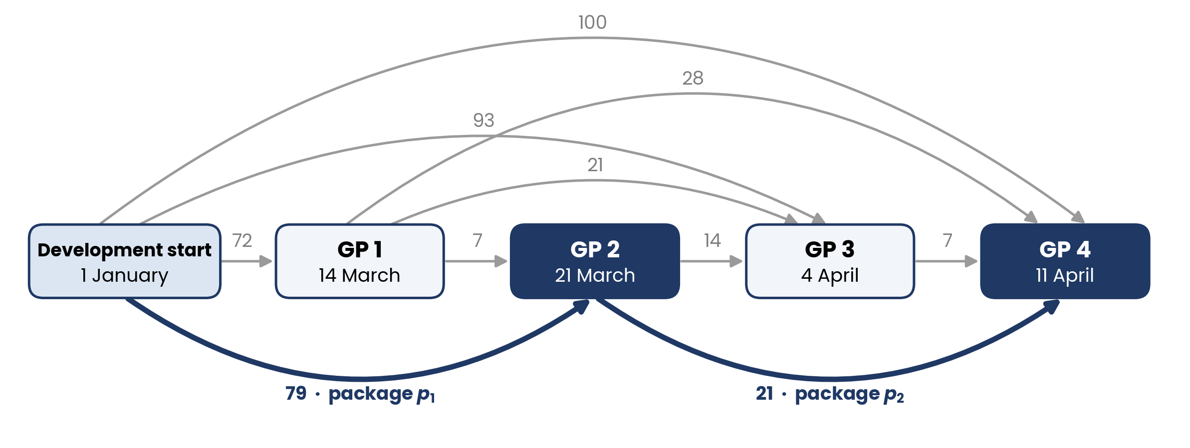
Figure 2 – Example graph with edge weights expressed in days; a plan with two debuts is highlighted

5.4 Algorithm
The optimal plan is searched for through a recursive visit of the graph. The state of the recursion includes the current node, the packages still to be assigned, the remaining budget, and the accumulated value and cost. At each step the algorithm evaluates, for each following node and each available package, the corresponding assignment and, if it satisfies the constraints, continues from the new node. Every visited node is a candidate solution, since the plan may exclude some packages. Identical packages are handled as counters per type, so as to avoid exploring equivalent permutations.
The optimisation is divided into two phases, which use the same recursion with different comparison criteria. The first phase determines the plan of maximum value; for equal value, the one with the lower cost prevails:
$V_{1}=\text{max}∑V(p,i)$ (8)
V₁ value of the optimal plan of the first phase
C₁ cost of the same plan [M$]
In the second phase, among the plans whose value is not lower than (1 − δ) · V₁, the one that maximises the net value is selected:
$\text{max}∑[λ V(p,i)-C(p,i)] \text{with} ∑V(p,i)≥(1-δ) V_{1}, λ=\frac{C_{1}}{V_{1}}$ (9)
δ performance tolerance chosen by the user
λ implicit price of performance [M$ per unit of value]
The parameter λ expresses the cost incurred, in the first-phase solution, for each unit of value: a less performing plan prevails only if the saving obtained exceeds λ for each unit of value given up. With δ = 0 the result coincides with the pure performance optimum.
Since the number of possible plans grows combinatorially, the recursion abandons early the branches that cannot lead to a better solution than the one already found. A branch is interrupted when:
• the remaining budget does not allow any of the remaining packages to be produced;
• no following node can be reached within the required times;
• the maximum value still achievable does not exceed that of the best solution found or, in the second phase, does not reach the threshold (1 − δ) · V₁.
The maximum achievable value is estimated by excess, adding for each remaining package the highest value obtainable in any reachable race, without considering the other packages: the estimate therefore never excludes the optimal solution. The reachable races and the corresponding maximum values are calculated before the search for each node and package type, so as not to repeat the calculation during the recursion.
At the end of the process, each package excluded from the plan is associated with the reason for its exclusion: impossibility of placing it in any race, cost higher than the available budget, insufficient remaining budget, or exclusion in favour of other packages.

6. Class diagram
Figure 3 shows the classes that make up the main structure of the application, organised according to the Model-View-Controller architecture: the main module instantiates View, Controller and Model; the View, built with the Flet library, collects the user's inputs and notifies the events to the Controller, which checks their validity and calls the methods of the Model. The Model accesses the database exclusively through the DAO class, which obtains the connections from DBConnect. Within the Model, the optimize_pre_season and optimize_in_season methods are the entry points of the two modes and call the recursive method _recursion described in section 5. To limit the size of the figure, related methods and attributes are shown on the same line.
The regulatory constants and the model parameters are collected in a separate module, constants, not shown in the diagram since it contains no application logic: by changing its values, the application can be adapted to different regulations or assumptions without modifying the rest of the code.
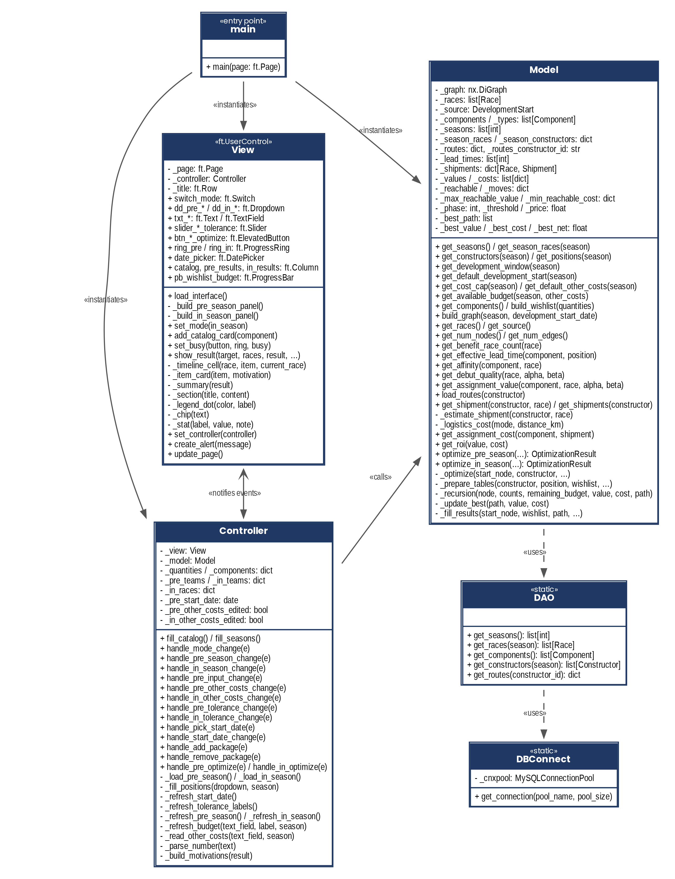
Figure 3 – Class diagram: MVC architecture and data access
Figure 4 shows the domain classes, which act as data containers and are therefore described by their attributes only, with the exception of WishlistItem and OptimizationResult, which expose some calculation methods. Race and DevelopmentStart are the two node types of the graph: the first represents a race in the calendar, at which a package can debut, while the second represents the development start date and is the starting node of the search in the Pre-Season mode; in the In-Season mode the search starts instead from the race from which the plan is recalculated. Component and Constructor represent respectively the catalogue types and the teams, read from the database. WishlistItem describes a single package requested by the user and, at the end of the optimisation, reports its outcome; Shipment represents the shipment of the components to the circuit of a race; OptimizationResult collects the summary of the plan, with the results of the two phases and the execution times.
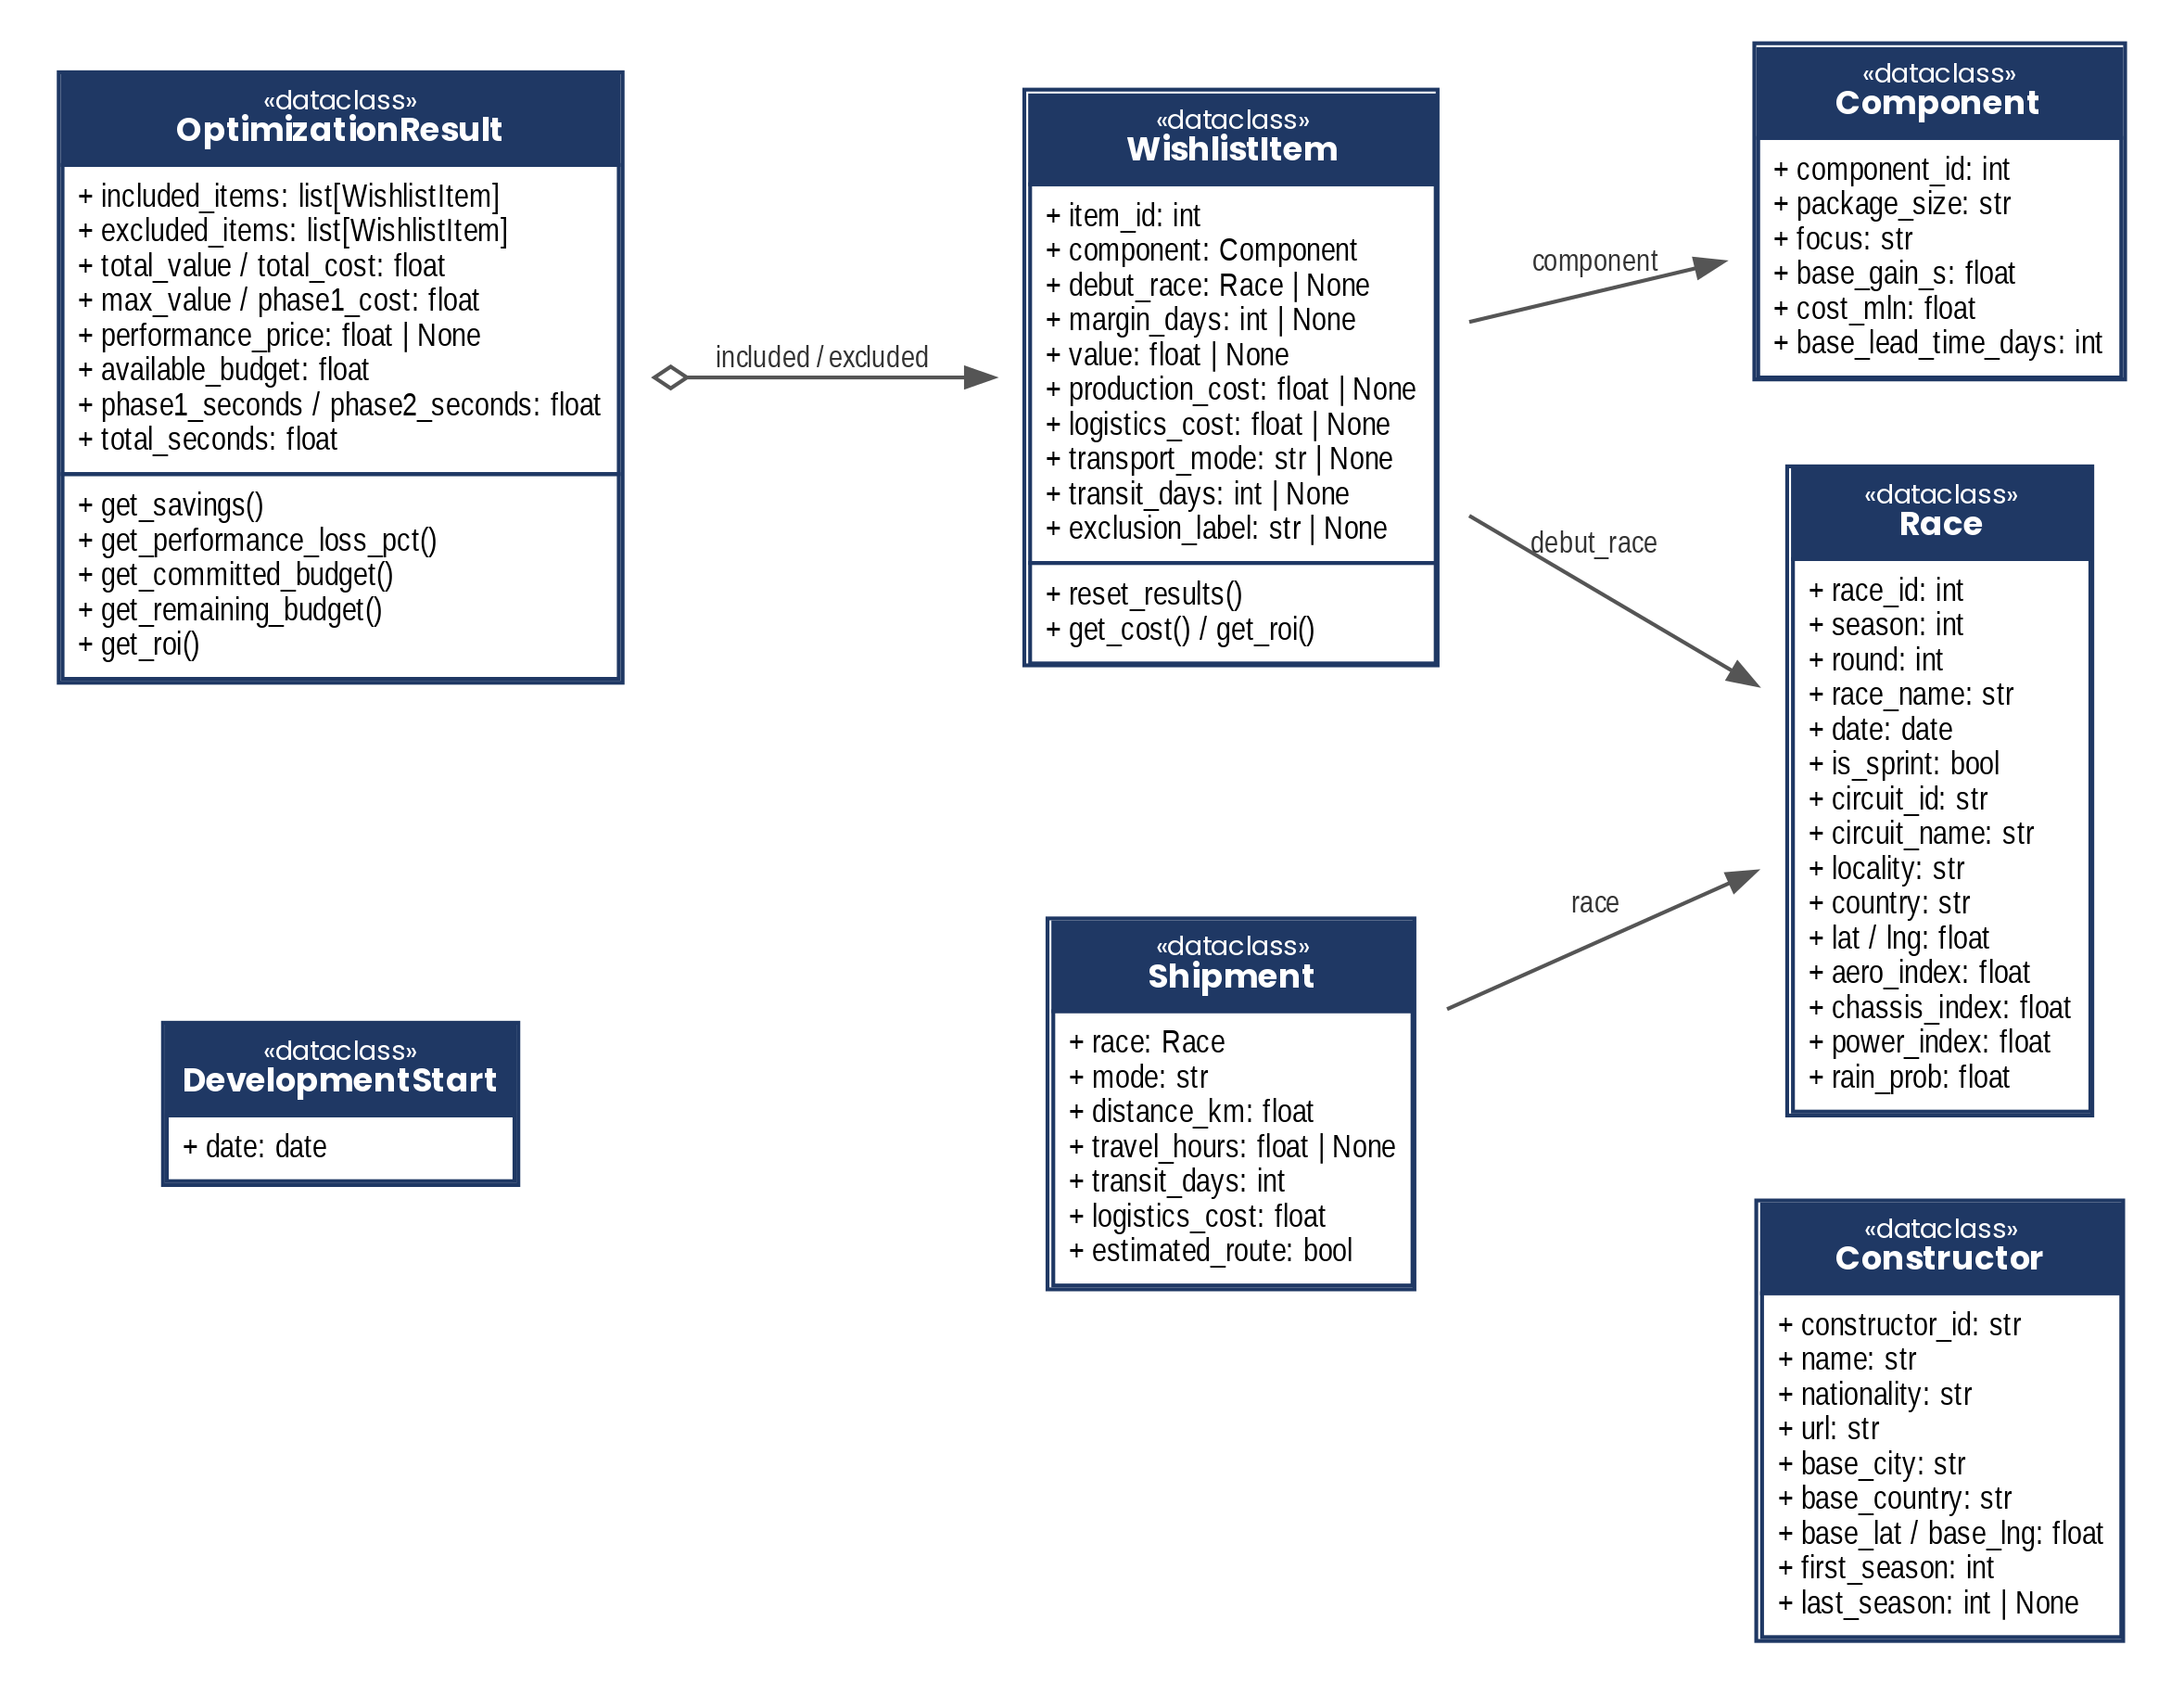
Figure 4 – Class diagram of the domain

7. Application screenshots and demonstration video
The application interface is divided into the two modes described in section 3, which can be selected with the switch at the top. The following screenshots refer to the 2027 season and illustrate, for each mode, data entry and the presentation of the results.

7.1 Pre-Season mode
At start-up the application opens in the Pre-Season planning mode (Figure 5). The Scenario section collects the season, the team, the target championship position, the development start date and the other expenses falling within the cost cap; the available budget B is recalculated at each change as the difference between the season cost cap and the other expenses. The slider below sets the performance tolerance δ. The Wishlist section presents the catalogue of the six package types, coloured according to their focus, with the cost, the nominal gain and the effective production time, updated according to the selected position; the side panel summarises the number of packages chosen, the production cost compared with the available budget and the overall nominal gain.
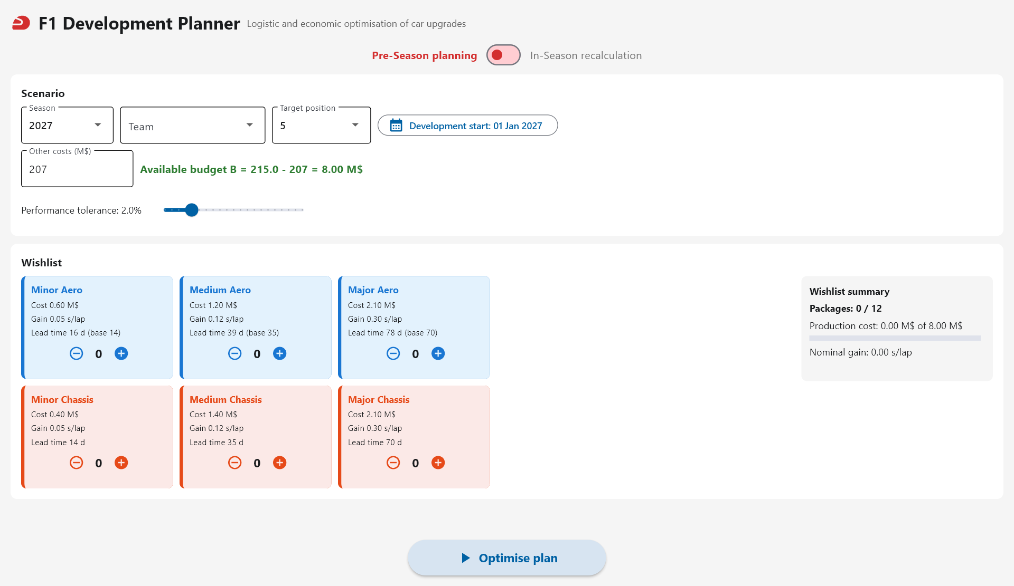
Figure 5 – Initial screen of the Pre-Season mode
The development start date is selected through a calendar (Figure 6), limited to the window allowed for the chosen season.
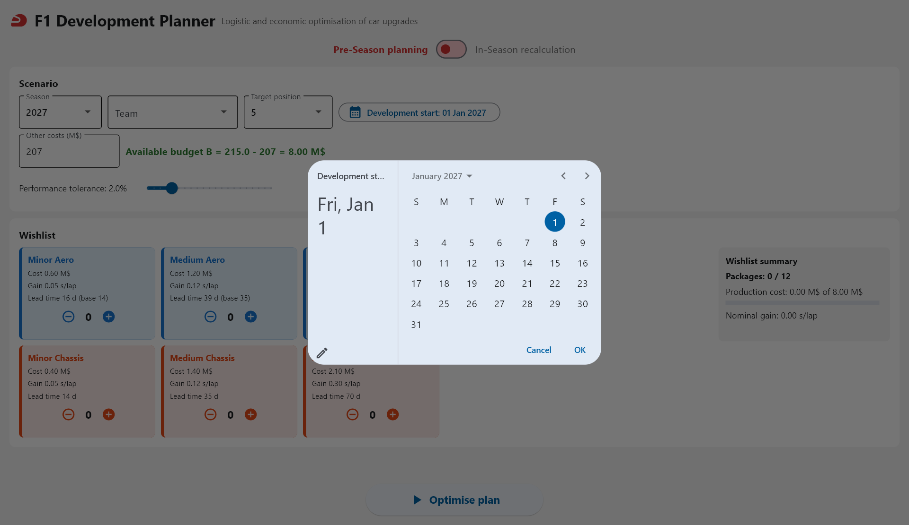
Figure 6 – Selection of the development start date
Figure 7 shows the scenario used as an example: Ferrari, target position 1, an available budget of 8 M$, a tolerance of 2% and a wishlist made up of one package for each type, with a production cost of 7.80 M$. Since position 1 corresponds to the lowest share of aerodynamic testing, the production times of the Aero packages are longer than the base ones: the Major Aero package, for example, requires 100 days instead of 70.
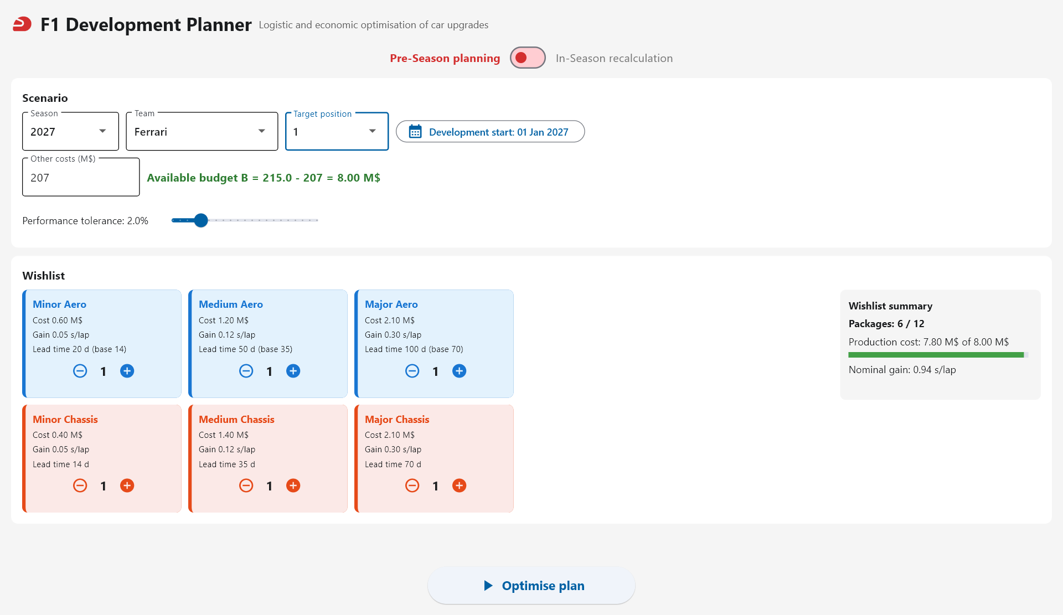
Figure 7 – Example scenario in the Pre-Season mode
Once the optimisation has been launched, the Season timeline section (Figure 8) places the debuts on the season calendar, coloured according to their focus, and marks the weekends with a Sprint race. In the example the three Chassis packages, which have shorter production times, debut in the first part of the season, in Saudi Arabia, Miami and Canada, while the Aero packages debut at Monza and in Turkey.
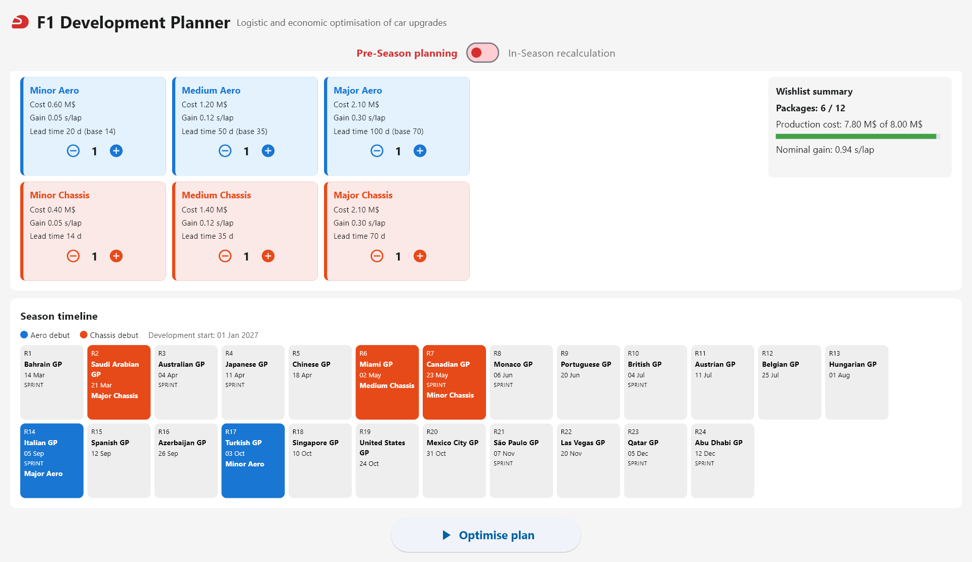
Figure 8 – Debut calendar of the example scenario
The lower part of the page (Figure 9) shows the details of the plan. For each included package the debut race, the days of delivery margin, the value V, the production cost, the logistic cost with the means of transport and the travel days, the ROI and an explanation are shown; the explanation recalls the affinity with the circuit, the type of weekend, the probability of rain and the number of races in which the package delivers a benefit. The Not included section lists the excluded packages with the corresponding reason: in the example the Medium Aero is excluded by the second phase, which gives up 1.71% of the maximum performance, within the 2% tolerance, in exchange for a saving of 1.20 M$. Finally, the Summary section reports the committed and remaining budget, the overall value, the maximum value of the first phase, the price of performance λ, the saving, the overall ROI and the computation times of the two phases.
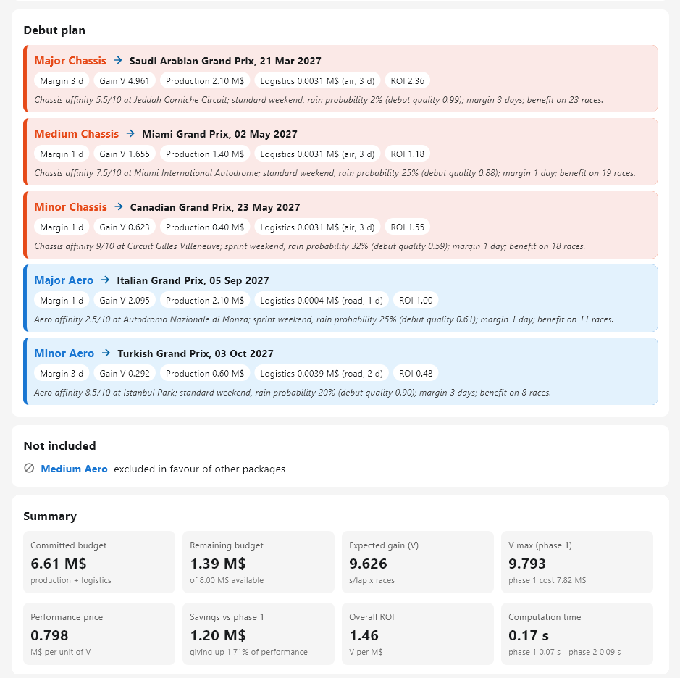
Figure 9 – Plan details, excluded packages and summary of the example scenario

7.2 In-Season mode
In the In-Season recalculation mode (Figure 10) the Scenario section requires, in addition to the season and the team, the current Grand Prix, the current championship position, the package to be placed and the updated other expenses, which include the packages already decided.
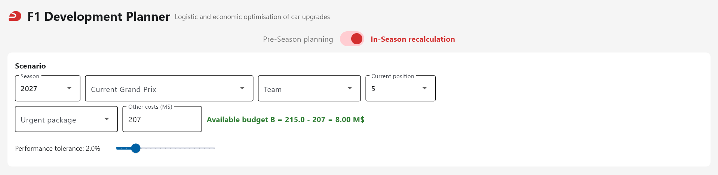
Figure 10 – Initial screen of the In-Season mode
Figure 11 shows a recalculation for a Medium Chassis package, with Ferrari in second position at the Monaco Grand Prix and an available budget of 6 M$. In the calendar the races already held are shown in grey and the current Grand Prix is highlighted with the label NOW. The package debuts in Belgium, with a 10-day margin, and delivers a benefit over the remaining 13 races.
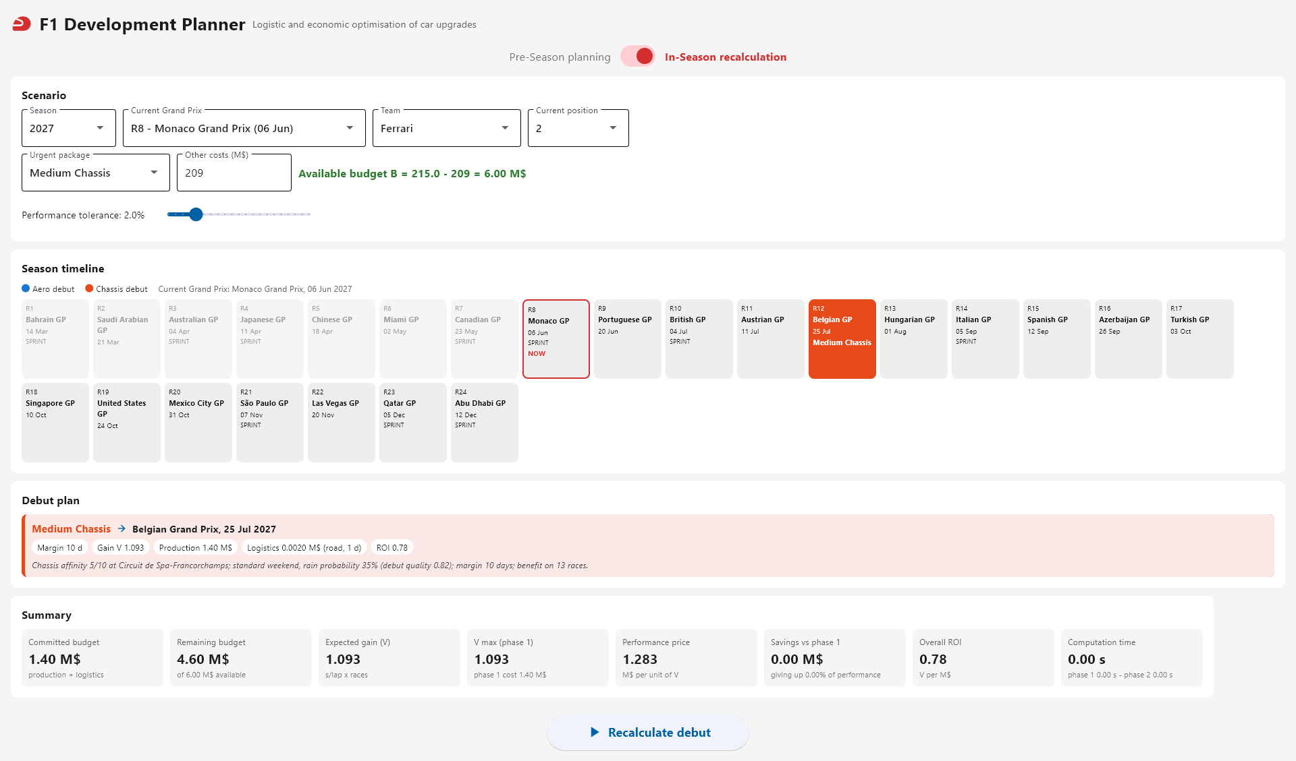
Figure 11 – In-Season recalculation of a Medium Chassis package

7.3 Demonstration video
The operation of the application is illustrated in the demonstration video in Italian language available at the following address: https://youtu.be/n1bTftE29iw

8. Experimental results

8.1 Test configuration
The experiments were carried out by calling the optimisation methods of the Model directly and varying only the data that the user can enter through the interface; the model constants, including α, β and Δ, were left unchanged.
Except for the parameter varied each time, all the experiments adopt the following reference configuration:
• Season and team: 2027, Ferrari.
• Target position: 1.
• Available budget: 8 M$.
• Performance tolerance: 2%.
• Development start: 1 January 2027.
• Wishlist: nine packages, one Major, two Medium and two Minor of the Aero type and one Major, one Medium and two Minor of the Chassis type, with an overall production cost of 10.00 M$.
Since the cost of the wishlist exceeds the available budget, the algorithm has to select the packages to be included.

8.2 Target position
Table 2 compares the debuts obtained with target positions 1 and 5; in both cases one Minor Aero and the two Medium Aero packages are excluded.
Table 2 – Plan debuts for target positions 1 and 5
Package | Position 1: Grand Prix | V | Position 5: Grand Prix | V
Major Chassis | Saudi Arabia (21/03) | 4.961 | Saudi Arabia (21/03) | 4.961
Medium Chassis | Miami (02/05) | 1.655 | Spain (12/09) | 0.890
Minor Chassis | Canada (23/05) | 0.623 | Austria (11/07) | 0.487
Major Aero | Italy (05/09) | 2.095 | Portugal (20/06) | 3.400
Minor Chassis | Azerbaijan (26/09) | 0.327 | Hungary (01/08) | 0.434
Minor Aero | United States (24/10) | 0.207 | Turkey (03/10) | 0.292
V₁ / V of the plan |  | 9.967 / 9.869 |  | 10.647 / 10.464
Cost C (M$) |  | 7.016 |  | 7.018
In position 5 the production time of the Major Aero falls from 100 to 78 days: the package debuts in Portugal instead of Monza and the Chassis packages shift to the second part of the season. The value of the plan increases by 6.0% at equal cost.

8.3 Available budget
Table 3 reports the results as the available budget varies.
Table 3 – Results as the available budget varies
B (M$) | V₁ | V | C (M$) | Remaining budget (M$) | Packages included | Excluded for budget | Excluded in favour of others
5.0 | 8.405 | 8.405 | 4.608 | 0.392 | 3 | 6 | 0
6.5 | 9.662 | 9.662 | 6.413 | 0.087 | 5 | 4 | 0
8.0 | 9.967 | 9.869 | 7.016 | 0.984 | 6 | 2 | 1
10.0 | 9.967 | 9.869 | 7.016 | 2.984 | 6 | 0 | 3
12.0 | 9.967 | 9.869 | 7.016 | 4.984 | 6 | 0 | 3
Up to 6.5 M$ the budget is the binding constraint: with 5 M$ only three packages are included and the Major Aero, second in the production sequence, brings its debut forward to Great Britain. From 8 M$ upwards the plan no longer changes, because the limit becomes the calendar: the Medium Aero packages move from exclusion for budget to exclusion in favour of other packages.

8.4 Performance tolerance
Table 4 and Figure 12 report the effect of the tolerance δ; in all cases the first phase yields V₁ = 9.967 and C₁ = 7.619 M$.
Table 4 – Results as the tolerance δ varies
δ (%) | V | C (M$) | Saving (M$) | Loss (%) | Packages included
0 | 9.967 | 7.619 | 0.000 | 0.00 | 7
1 | 9.869 | 7.016 | 0.603 | 0.99 | 6
2 | 9.869 | 7.016 | 0.603 | 0.99 | 6
3 | 9.869 | 7.016 | 0.603 | 0.99 | 6
4 | 9.662 | 6.413 | 1.206 | 3.07 | 5
5 | 9.662 | 6.413 | 1.206 | 3.07 | 5
6 | 9.662 | 6.413 | 1.206 | 3.07 | 5
7 | 9.354 | 6.013 | 1.606 | 6.16 | 4
8 | 9.354 | 6.013 | 1.606 | 6.16 | 4
9 | 9.081 | 5.612 | 2.007 | 8.89 | 5
10 | 9.081 | 5.612 | 2.007 | 8.89 | 5
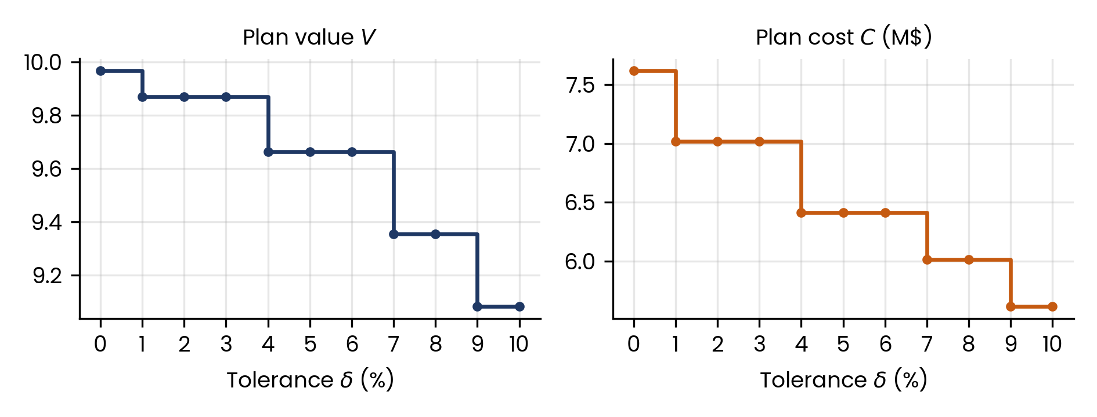
Figure 12 – Value and cost of the plan as the tolerance δ varies
The solution changes only for δ equal to 1, 4, 7 and 9%, when the threshold (1 − δ) · V₁ allows a package to be given up or a combination to be replaced. With δ = 9% the plan includes one package more than with δ = 7%: the second phase does not reduce the number of packages, but maximises the net value.

8.5 Development start date
Table 5 reports the results as the development start date varies. As the start is delayed, the value decreases and the composition of the plan changes: starting from the third or fourth Grand Prix only one Major is included.
Table 5 – Results as the development start date varies
Development start | V₁ | V | C (M$) | Included (Major / Medium / Minor) | Major debuts
01/09/2026 | 11.187 | 10.980 | 7.216 | 2 / 2 / 1 | Aero: Bahrain; Chassis: Portugal
01/01/2027 | 9.967 | 9.869 | 7.016 | 2 / 1 / 3 | Chassis: Saudi Arabia; Aero: Italy
04/04/2027 (GP 3) | 5.588 | 5.562 | 5.517 | 1 / 1 / 4 | Chassis: Portugal
11/04/2027 (GP 4) | 4.998 | 4.900 | 4.912 | 1 / 1 / 3 | Chassis: Great Britain

8.6 Season
Table 6 compares the 2027 and 2024 seasons, both with 24 races. In 2024 the Major Aero debuts earlier, in Great Britain, but the plan includes one package fewer.
Table 6 – Plan debuts in the 2027 and 2024 seasons
Package | 2027: Grand Prix | V | 2024: Grand Prix | V
Major Chassis | Saudi Arabia (21/03) | 4.961 | Australia (24/03) | 4.757
Medium Chassis | Miami (02/05) | 1.655 | Netherlands (25/08) | 0.842
Minor Chassis | Canada (23/05) | 0.623 | Azerbaijan (15/09) | 0.294
Major Aero | Italy (05/09) | 2.095 | Great Britain (07/07) | 2.721
Minor Chassis | Azerbaijan (26/09) | 0.327 | United States (20/10) | 0.184
Minor Aero | United States (24/10) | 0.207 | excluded | –
V₁ / V of the plan |  | 9.967 / 9.869 |  | 8.977 / 8.798
Cost C (M$) |  | 7.016 |  | 6.415

8.7 Team base
The comparison between Racing Bulls, based in Faenza, and McLaren, based in Woking, is carried out in position 5 (Table 7).
Table 7 – Debuts and shipments for the Faenza and Woking bases (position 5)
Grand Prix | Faenza: package | Shipment | Cost (k$) | Woking: package | Shipment | Cost (k$)
Saudi Arabia | Major Chassis | air, 3 days | 3.1 | Major Chassis | air, 3 days | 3.1
Portugal | Major Aero | road, 2 days | 4.9 | Major Aero | road, 2 days | 4.5
Austria | Minor Chassis | road, 1 day | 1.2 | Minor Aero | road, 1 day | 3.0
Hungary | Minor Chassis | road, 1 day | 1.8 | Minor Chassis | road, 1 day | 3.6
Spain | Medium Chassis | road, 1 day | 3.5 | Medium Chassis | road, 2 days | 3.2
Turkey | Minor Aero | road, 2 days | 3.9 | Minor Chassis | air, 3 days | 3.1
Total |  |  | 18.4 |  |  | 20.5
From Woking the Istanbul circuit is more than 2,000 km away and requires air transport, one day longer than road transport from Faenza: the Minor Aero would arrive late. For McLaren the algorithm therefore places the Minor Chassis in Turkey and brings the Minor Aero forward to Austria, where the affinity is lower; the value falls from 10.464 to 10.437. The overall logistic cost, by contrast, differs by about 2 k$, 0.03% of the cost of the plan: the model only considers the dedicated shipment of the new components, while the ordinary transport of team equipment falls within the other expenses.

8.8 Debut choice in the In-Season mode
A Medium Aero package was recalculated in the In-Season mode starting from each Grand Prix, with Ferrari in position 1 (Table 8).
Table 8 – First reachable race and chosen race for a Medium Aero package
Recalculation from GP | First reachable race | V | Chosen race | V
Miami | Great Britain | 1.195 | Great Britain | 1.195
Canada | Belgium | 1.040 | Belgium | 1.040
Monaco | Hungary | 0.967 | Hungary | 0.967
Portugal | Italy | 0.838 | Spain | 0.845
Great Britain | Italy | 0.838 | Spain | 0.845
Austria | Italy | 0.838 | Spain | 0.845
Belgium | Azerbaijan | 0.757 | Azerbaijan | 0.757
Hungary | Azerbaijan | 0.757 | Azerbaijan | 0.757
As a rule, the algorithm chooses the first reachable race, which extends the benefit to the largest number of races. When this is Monza, a Sprint weekend on a circuit with low aerodynamic affinity, the debut is postponed to Madrid, where the value is higher; the same happens for a Major Aero package recalculated from Miami and from Canada.

8.9 Computation times
Table 9 reports the computation times as the size of the wishlist varies, with packages evenly distributed across the types and the other data of the reference configuration.
Table 9 – Computation times as the size of the wishlist varies
Packages | First phase (s) | Second phase (s) | Total (s)
3 | 0.0002 | 0.0002 | 0.002
6 | 0.017 | 0.022 | 0.041
9 | 0.257 | 0.306 | 0.565
12 | 1.210 | 1.274 | 2.487
Computation time grows rapidly with the number of packages, consistently with the combinatorial nature of the problem, but remains within a few seconds even with 12 packages, the maximum size allowed. With the same wishlist, the time also depends on the target position, since shorter production times make more races reachable. An In-Season recalculation takes less than one millisecond.

9. Evaluation and conclusions

9.1 Strengths
The main strength of the application is its ability to return a complete development plan in a matter of moments, while taking into account many factors at the same time: production times, budget, circuit characteristics, weekend conditions and logistics. A decision that usually stems from experience and separate assessments thus becomes structured, repeatable and comparable.
The result is not limited to a sequence of dates. The user decides how much performance they are willing to sacrifice to contain spending, and the application makes the price of this choice explicit. Each debut comes with an explanation and each exclusion with its reason, so that the plan can be understood and discussed rather than accepted as a black box. As the experiments show, the plan responds consistently to every change in the inputs, and the speed of the calculation allows several scenarios to be compared within the same working session.
The application is also flexible. The two modes cover the entire decision cycle, from pre-season planning to the choices made during the championship, and the separation between data and logic makes it possible to adapt it to different teams, seasons and regulations without changing the algorithm. The result is a practical tool, designed to support decision-makers and to make their choices more informed.

9.2 Weaknesses
The most significant limitation concerns the data. Teams do not publish the costs, gains and production times of their upgrades: the catalogue values, the indices describing the circuits, the weights assigned to rain and to the Sprint format and the transport assumptions are therefore estimates built from public sources. The plans produced should thus be read as indications of the behaviour of the model rather than as precise forecasts.
This limitation is, however, mitigated by the way the application has been built, which separates data from logic. The package catalogue and the circuit characteristics are stored in the database, while the model parameters, the logistic assumptions and the values set by the regulations are collected in the constants module. A team that has the real data could therefore easily update both the database and the constants module, without touching the algorithmic part of the code, and obtain considerably more accurate results.
Other limitations stem from the simplifications of the model. Production is represented as a single line that builds one package at a time, and the championship position, on which the aerodynamic testing allowed by the regulations depends, remains the same for the whole season. Moreover, the Pre-Season plan tends to concentrate the largest packages at the start of the championship, because they are the most rewarding; in reality these upgrades usually arrive after a few races, once the team has collected on track the data needed to design them.
The In-Season mode was introduced precisely to address these limitations. The recalculation starts from the current Grand Prix, when the team knows the actual behaviour of the car, and uses the real championship position and the expenses already incurred. Repeated at every decision point, for example every three or four races, it turns the initial plan into rolling-horizon planning, in which the initial strategy is corrected step by step with the most recent information. The only remaining limitation is that this mode places one package at a time and does not keep track of the decisions already taken, which the user accounts for by including them in the other expenses.

9.3 Contribution to the problem
With respect to the problem described in section 3, the application is a decision-support tool that helps establish which upgrades to produce with the available budget and at which Grand Prix they should debut, treating each package as an investment characterised by a cost, a lead time and a return. The experiments also suggest some managerial insights: above a certain threshold, increasing the budget does not improve the plan unless development times are also reduced; the team base affects delivery times more than costs; the aerodynamic testing scale penalises the top teams by delaying their upgrades.

9.4 Conclusions
The project has led to an application that, starting from public data, identifies the most effective development plan within the constraints of production, budget and calendar, and makes its choices understandable. The experimental results show that the tool captures non-obvious trade-offs, such as giving up a less convenient package or postponing a debut to a more favourable race, and provides useful insights beyond the single plan. Despite the limitations related to data availability, the application is a solid basis for supporting development decisions, which could become even closer to reality with a team's own data and with some further developments, such as the management of several parallel production lines and the possibility of recalculating several packages at once during the season, taking into account the decisions already taken.

References
[1] PlanetF1, “F1 Sprint changes formally approved as 2024 season takes shape”. https://www.planetf1.com/news/f1-2024-sprint-changes-formally-approved
[2] GPblog, “Zak Brown explains why McLaren's Miami upgrades are 'risky'”, 2024. https://www.gpblog.com/en/news/272592/zak-brown-discusses-the-upgrades-coming-to-mclaren-at-miami.html
[3] WeatherSpark, Historical climate and weather data. https://it.weatherspark.com/
[4] FIA, 2026 Formula 1 Regulations, Section D: Financial Regulations – F1 Teams, Issue 07, 25 June 2026. https://www.fia.com/system/files/documents/fia_2026_f1_regulations_-_section_d_financial_-_f1_teams_-_iss_07_-_2026-06-25.pdf
[5] FIA, 2026 Formula 1 Regulations, Section F: Operational, Issue 10, 5 August 2026, Article F4 “Aerodynamic Testing Restrictions”. https://www.fia.com/system/files/documents/fia_2026_f1_regulations_-_section_f_operational_-_iss_10_-_2026-08-05.pdf
[6] Brembo, Formula 1 media kit, circuit sheets. https://mediakit.brembo.com/index.php/circuits/f1-2022
[7] Tracing Insights, “All you need to know about the 2025 … Grand Prix”, race previews with the circuit characteristics provided by Pirelli. https://tracinginsights.com/blog/216484/all-you-need-to-know-about-the-2025-bahrain-grand-prix/
[8] R. Patel, Formula 1 Complete Dataset 1950–2026, Kaggle. https://www.kaggle.com/datasets/patelris/formula-1-complete-dataset-1950-2026
[9] Jolpica F1, Terms of Use. https://github.com/jolpica/jolpica-f1/blob/main/TERMS.md
[10] Formula1.com, “Formula 1 reveals calendar for 2027 season with 10 Sprint events”, 16 September 2026. https://www.formula1.com/en/latest/article/formula-1-reveals-calendar-for-2027-season-with-10-sprint-events.5J8ePLyjRuMyWEIDNUKgY4
[11] Autosport, “Where are F1 teams based?”. https://www.autosport.com/f1/news/where-are-f1-teams-based/10348715/
[12] Motorsport.com, “Cadillac to run F1 2026 operation from Silverstone while US base under construction”. https://www.motorsport.com/f1/news/cadillac-to-run-f1-2026-operation-from-silverstone-while-us-base-under-construction/10760242/
[13] J. Elson, “How much does an F1 car cost?”, Motor Sport Magazine, 14 January 2025. https://www.motorsportmagazine.com/articles/single-seaters/f1/how-much-does-an-f1-car-cost/
[14] B. Anderson, J. Noble, “Why F1's upgrade war is so unusual in 2026”, The Race. https://www.the-race.com/formula-1/why-f1s-upgrade-war-is-so-unusual-in-2026/
[15] Formula1.com, “Mercedes new sidepods worth 0.25s”. https://www.formula1.com/en/latest/article.mercedes-new-sidepods-worth-0-25s.3EGQeNQkA8WsiuCcqykuke.html
[16] Project OSRM, Open Source Routing Machine, on © OpenStreetMap contributors data, ODbL licence. https://project-osrm.org/
Last access to online resources: October 2026.

